To create our first program from your SAP you can either key in transaction SE38 or you can navigate to the ABAP Editor through the SAP menu tree.

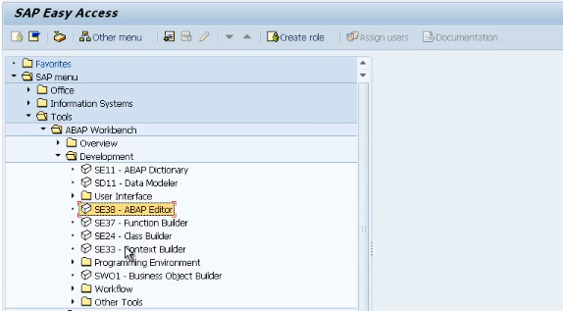

Go to tools, ABAP Workbench Developments and there you'll see SE38 ABAP Editor. Double click and execute it.

Now, just before we create out program, just something to keep in mind. Try and keep your programs as simple as possible do not make your programs any more complicated than they need to be. Now I say this because, through my many years of experience with SAP, more often than not, you have to pick up somebody else's program, try and understand it, and either make enhancements to it, or fix bugs that have been identified sometime after it has gone live. The worst thing in the world is opening up a program and seeing 100 and 100 of 1000 lines of code with very few comments and it takes just an absolute age to understand. I advise you all to keep things really simple. Add lots of comments into your code, so that anybody else, and yourself, that comes to look at the program later on, can easily understand what the program is doing, and the flow of the logic as it's executed. It makes everybody's life just that much easier. So, let's get going.

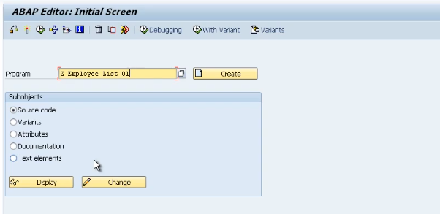

We'll enter our first program name. Now remember, we have to use our customer naming conventions. In this case that means we're going to start the program with the letter Z. After a Z, you can name it whatever you want we're going to stick with the employee theme. That we used when we created our table.

So, I'm going to enter Z_employee_list_01. Ensure that the source code radio button is selected. And then click the Create button.

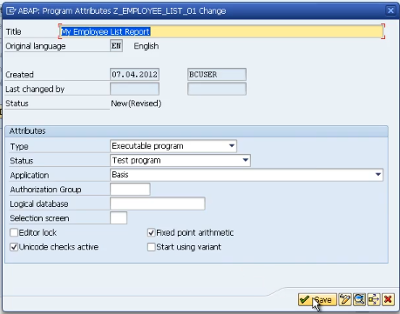

We're then presented with this Program Attributes window. Ensure that the original language is set to EN, which it is by default. Now come down to the attributes and you'll see the type click the drop-down button and select executable program now this mean our program can be executed without the need for us to create a transaction code. Now we don't need to touch any other field here. now just go ahead and click the Save button.

You should be familiar with this object directory entry box. And because we're not going to be transporting our programs, just click the local object button to assign our program to our temporary development class. And now you've made it you finally got to the coding screen.